Lab 4
Lab Statement 1: Capturing FTP packets using Wireshark
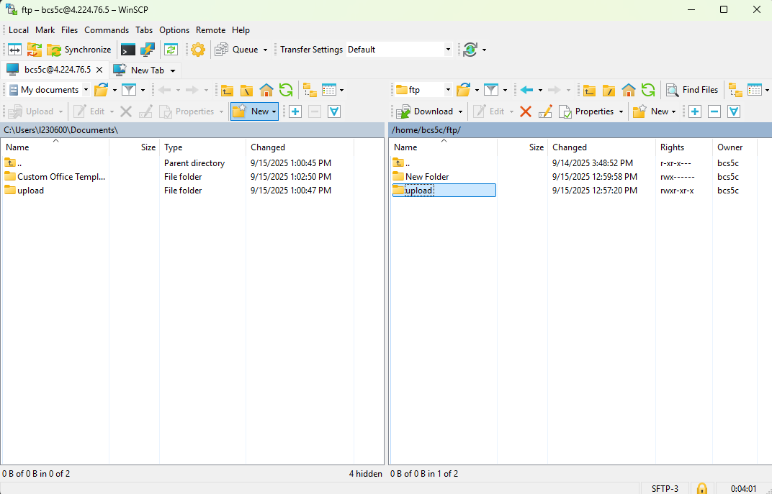
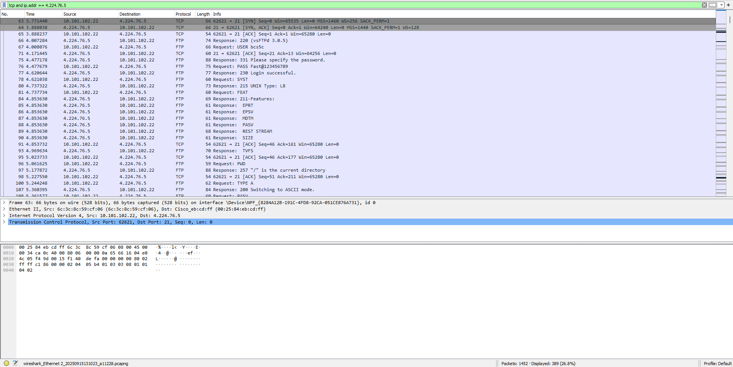

Q. What is the TCP port number for the FTP control connection? Describe the initial messages exchanged between your client and the server to establish this connection (e.g., TCP handshake, FTP welcome message).
A. TCP Port: 21
Q. Find the packets where your client sends the username and password. Are these credentials encrypted? What FTP commands are used for this (e.g., USER, PASS)?
A. Not encrypted. USER, ACK, PASS are used.
Q. FTP uses a separate data connection to transfer files and list directories. Find the packets that establish this second connection. Is the TCP port for this data connection the same as the control connection? Explain your observation.
A. No it is not the same, new port is 62621.
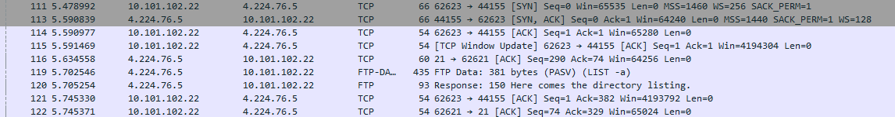
Q. Select the packets corresponding to your file download. What protocol is indicated in the “Protocol” column for these packets (FTP or FTP-DATA)? What does this tell you about how FTP separates commands from file contents?
A. FTP-DATA is used. FTP separates commands by using a separate TCP Port.
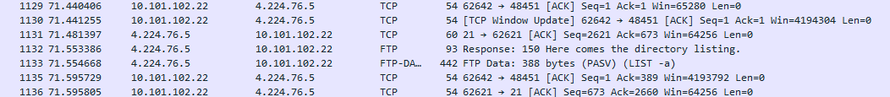
Q. Look at the FTP commands sent by your client (e.g., listing a directory). What command does the client send, and what is the server’s response code and message?
A. Command: LIST –a. Server response code and message: 150 Here comes the directory listing.
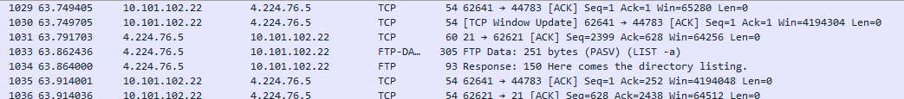

Q. Find the packet where your client ends the session. What FTP command is used to terminate the connection (e.g., QUIT)? What is the server’s final response code and message?
A. Request: TYPE A. Response: 200 Switching to ASCII mode.
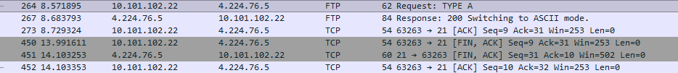

Lab Statement 2: Analyzing ICMP Packets using Wireshark
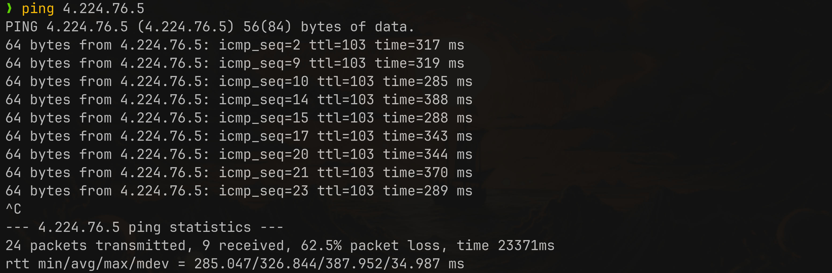


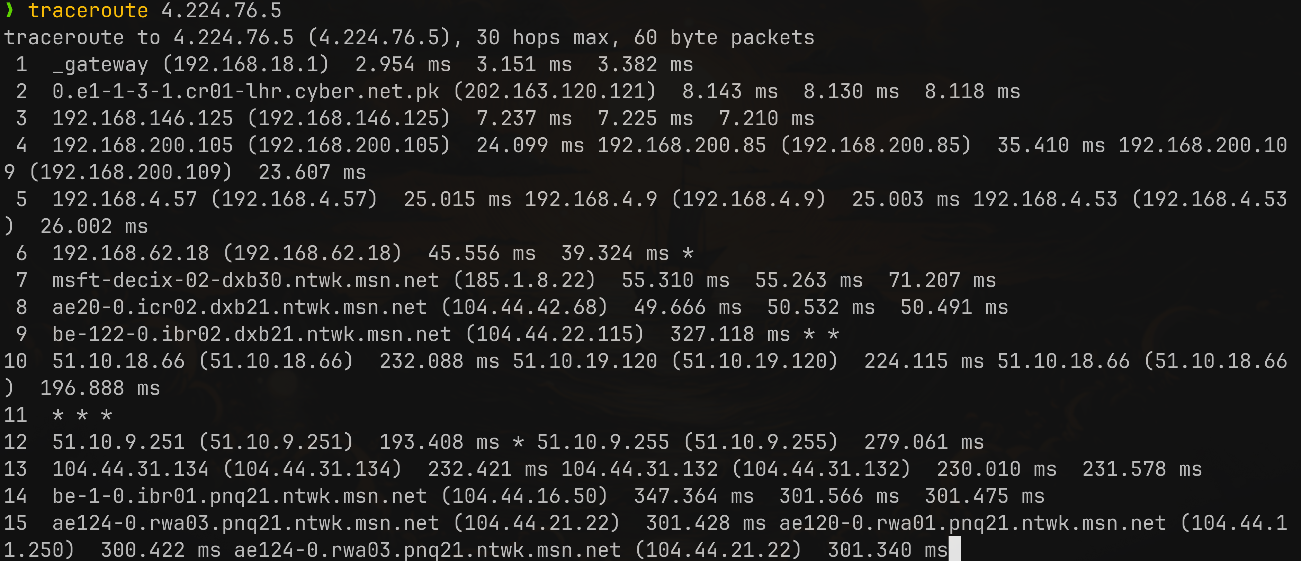
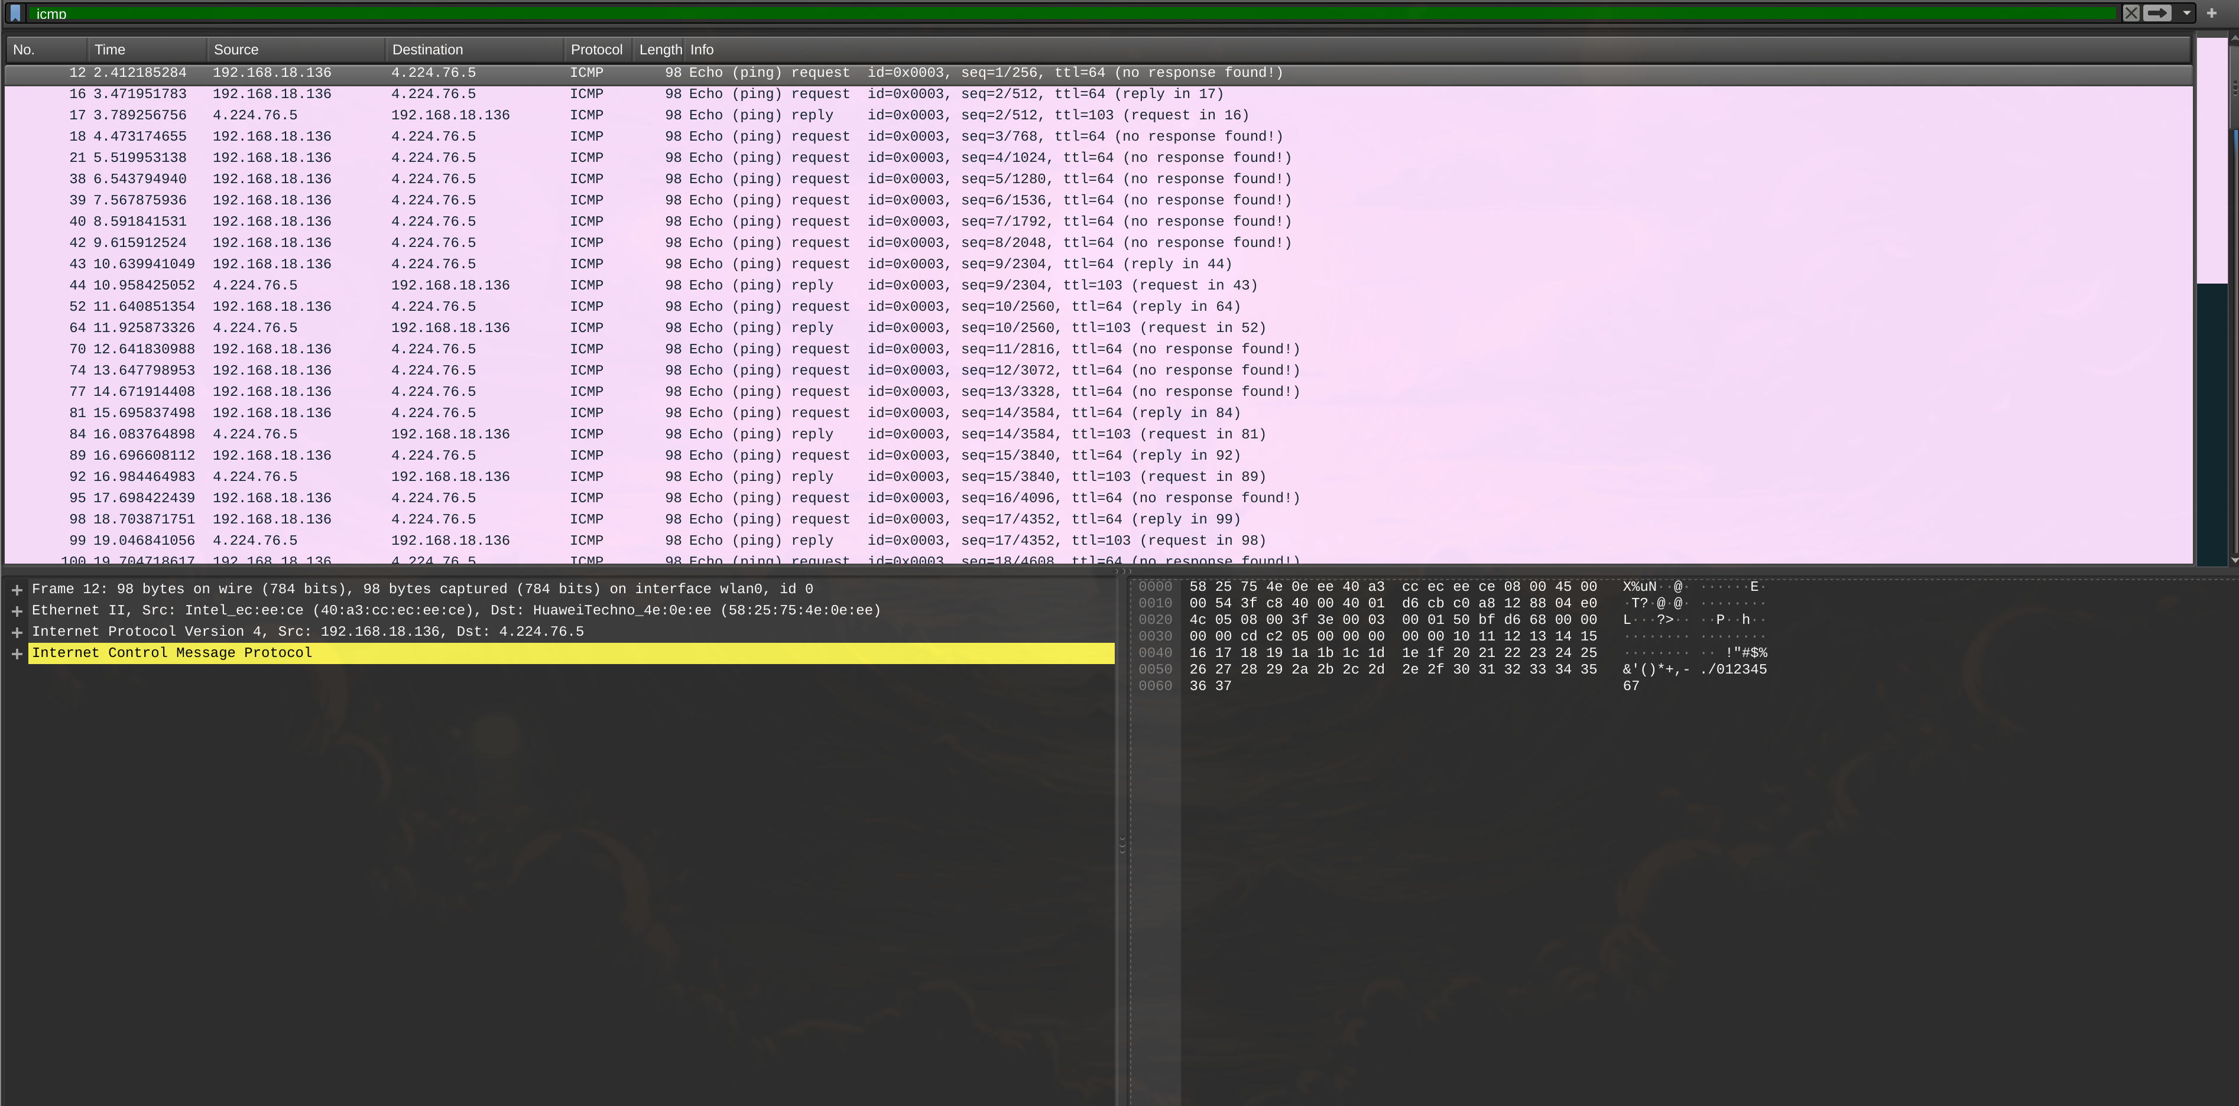
Analysis Questions:
1. Are ICMP messages sent over UDP or TCP?
A. Neither. They use ICMP protocol.
2. What is the link-layer (Ethernet) address of the host?
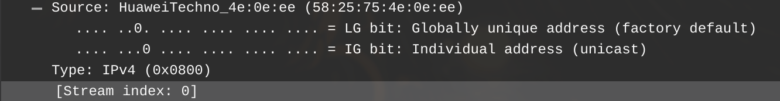
3. What kind of request is sent through these ICMP packets?
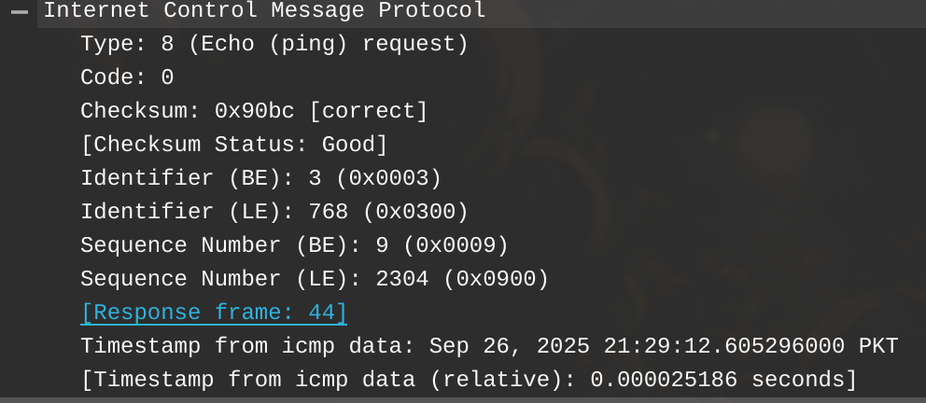

4. How many requests are sent by the host?
A. 26
5. What are the IP addresses of your host and the destination host?
A. My host: 192.168.18.136. Destination host: 4.224.76.5
6. Why doesn’t an ICMP packet have source and destination port numbers?
A. ICMP works at the network layer. Not the transport layer, so port numbers are not needed.
7. What values differentiate an ICMP request message from a reply message?
A. Type field is different for request and reply messages. Type 8 for request. Type 0 for reply.
8. Examine a ping request packet. What are the ICMP type and code numbers? How many bytes are the checksum, sequence number, and identifier fields?
A. ICMP type: 8. Code number: 0. Bytes of checksum: 4. Sequence number (BE): 20. Sequence number (LE): 768. Identifier (BE): 3. Identifier (LE): 5120.
9. Examine the corresponding ping reply packet. What are its ICMP type and code numbers?
A. ICMP type: 0. Code numbers: 0.
10. Examine packet no. 56. What are its ICMP type and code numbers?
A. ICMP type: 8. Code numbers: 0.
11. Why is an IP and TCP Header included in some ICMP messages? What do these headers depict?
A. ICMP messages include the IP header and first 8 bytes of the transport header of the original packet so that the sender can identify which connection caused the error. The IP header shows the source/destination addresses and protocol, while the TCP/UDP header snippet shows the source/destination ports and helps map the error to the correct application.

Lab Statement 3: Analyzing UDP Packets using Wireshark
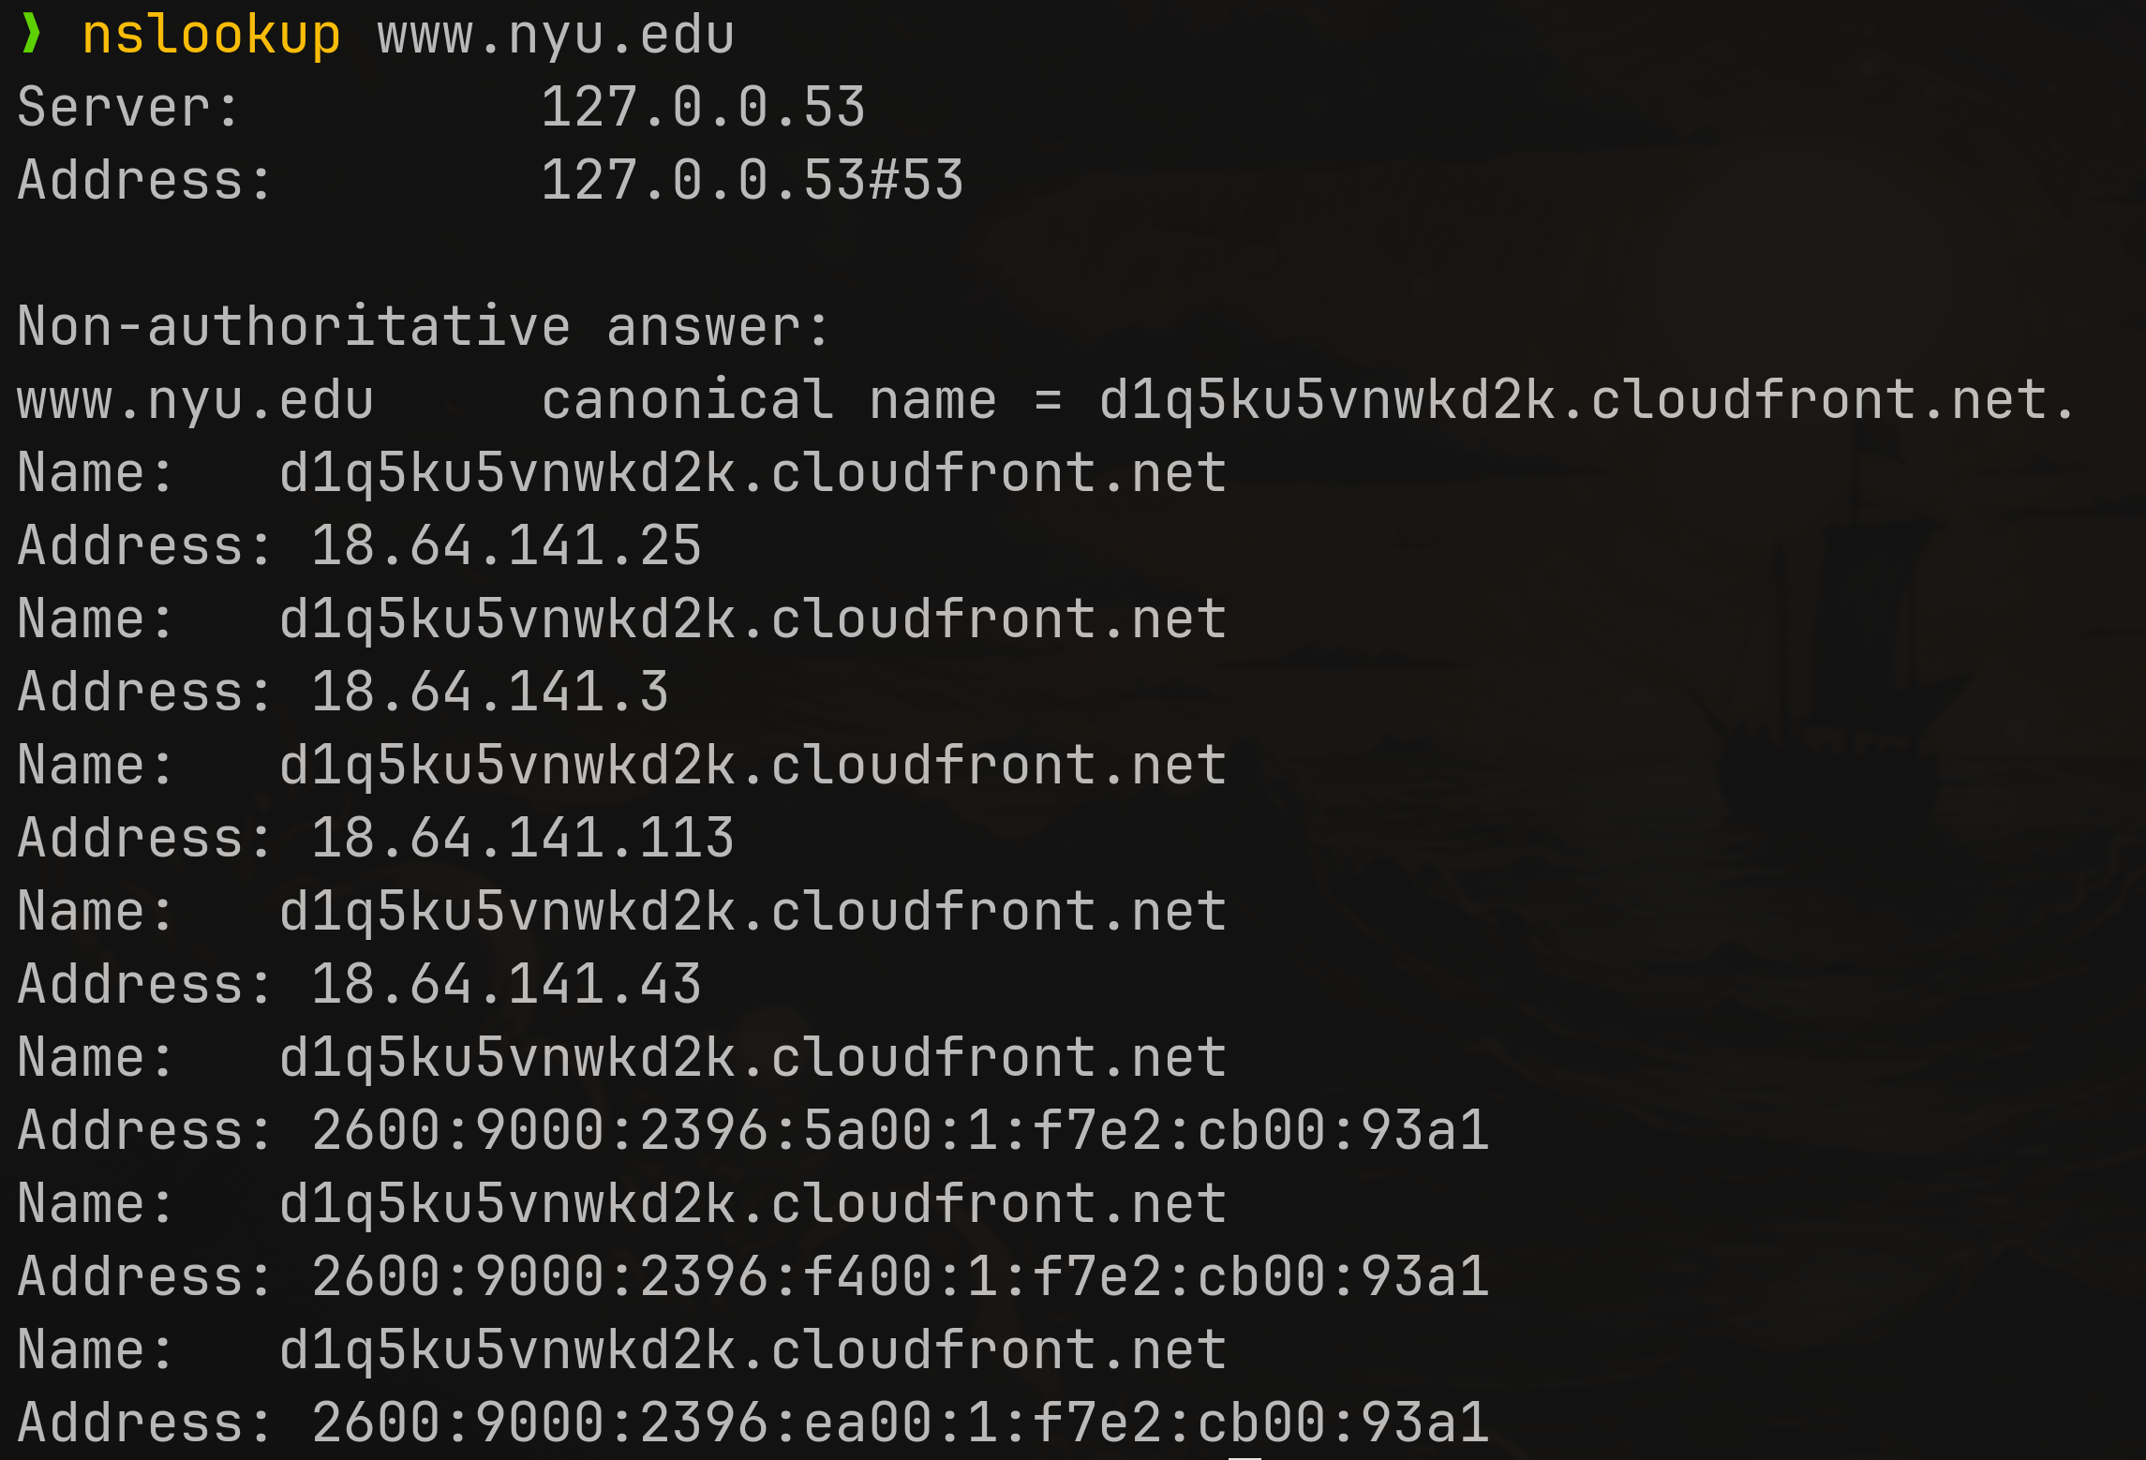
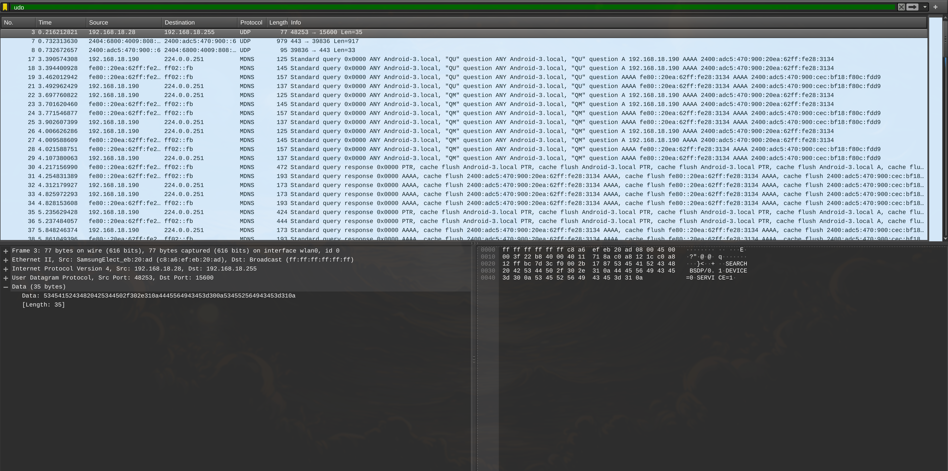
1. How many fields are in the UDP header, and what are their names and lengths in bytes?
A. The UDP header is 8 bytes long and contains 4 fields:
- Source Port – 2 bytes
- Destination Port – 2 bytes
- Length – 2 bytes
- Checksum – 2 bytes
2. The value in the UDP “Length” field refers to the length of what?
A. The UDP Length field specifies the total length in bytes of the UDP header (8 bytes) plus the UDP payload (data).
3. What is the maximum possible size of a UDP payload? What is the largest possible source port number?
A. Maximum UDP payload size: 65,507 bytes (65,535 − 8-byte UDP header − 20-byte IP header). Largest source port number: 65,535.
4. What is the protocol number for UDP (found in the IP header)?
A. 17.
5. Describe the relationship between the source and destination port numbers in the query and reply packets.
A. Source number in query becomes destination number in reply. And destination number in query becomes source number in reply, and you can say vice versa.

